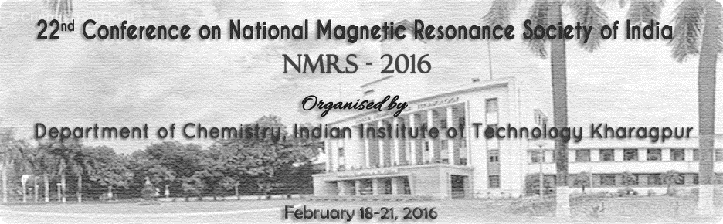

Registration form
Name of the Participant(s):
Designation: Sex: M / F

Address:

Mobile: Email:

Food Preference (tick one): Non-veg / Veg

Tentative Travel plan:

Arrival: Departure:

Registration details

Category:

Accommodation required: Yes/No Abstract Submitted: Yes/No

DD No. & Bank: Transaction details (for Bank transfer):

Amount:

Date: Signature:
----------------------------------------------------

------------------------------------------------------------------------------------
Signature & Seal of competent authority of the Institute (for students)
Please complete and return the Registration form by email to: nmrs2016@chem.iitkgp.ernet.in. Registration confirmation will be made on receipt of registration fees. The DD/Bank transfer receipt should be sent to: Prof. Samik Nanda, Secretariat, NMRS-2016, Department of Chemistry, IIT Kharagpur 721302.
Deadline for Registration: December 31st, 2015

